Extended abstracts should be 3-4 pages

Title of the article (TIMES NEW ROMAN, 17 FONT SIZE, BOLD, ALL CAPS, CENTERED)
First Name Last Name of First Author ¹, First Name Last Name of second Author ², First Name Last Name of Third Author ³ (TIMES NEW ROMAN, 11 font size, Bold, Centered)
Affiliation: Department of ...OR Faculty of…, University (Institution) of..., City, Country³ (TIMES NEW ROMAN, 11 font size, Bold, Centered)
Received: 00.00.0000 Final revised: 00.00.0000 Accepted: 00.00.0000
Doi link:

Abstract (10 Font Size, bold, all caps, centered):
Abstract should be written in 200 words and with 10 font size, Times New Roman, justified, single line spacing. Objectives, methods and findings are summarized in this section.
Keywords: Keywords regarding the work are stated in this section. Said section should contain maximum 5 words that are written with 10 font size and seperated with semi-colon.

- INTRODUCTION (Title Times New Roman, 12 font size, bold, 200 words)
Extended abstracts should be written according to underlying structure of the structured abstract and in a form that is shorter than the full text. Subtitles of the extended abstract should be composed from the sections of abstract and keywords, introduction and objective, method, findings and argument, conclusion and suggestions. Extended abstract of the full paper shall be written with Times New Roman font, single line spacing and 11 font size. Extended abstracts can contain figures, tables, formulations or images. Extended abstracts should be in a structure that explains the content of the declaration therefore the preparation phase of the said work. Page margins are formed regarding the A4 page size and are 3 cm wide from the right, left, top and bottom. End of the lines should be aligned to the right and there should be no syllable segmentation. Extended abstracts should be 3-4 pages including the references and pages should not be numbered. Current literature regarding the work subject should be examined and the differences of the said work from the past, similar works should be presented clearly in the introduction section.

- MATERIALS AND METHODS
All materials and methods that have been used in the work must be stated clearly and subtitles should be used when necessary.
2.1. Subtitle
First degree titles (2.) should be written left aligned, all caps and bold. Second and 3rd degree subtitles
(2.1, 2.1.1) should be written left aligned, bold and with title case. A blank line should be placed between the paragraphs and there should not be any paragraph indentation.

- RESULTS AND DISCUSSION
  - Subtitle
All of the tables, images and figures should be centered. Figures and images should be numbered together (Figure 1) and figure definitions should be placed under the figure or image; as for the tables, they should also be numbered (Table 2) and the table header should be placed at the top of the chart. Table, image and figure headers should be written with upper case initial letters, bold and should be centered. References (if any) of the tables, figures and images should be presented just under the tables, figures and images in the form of author surname and publication date.

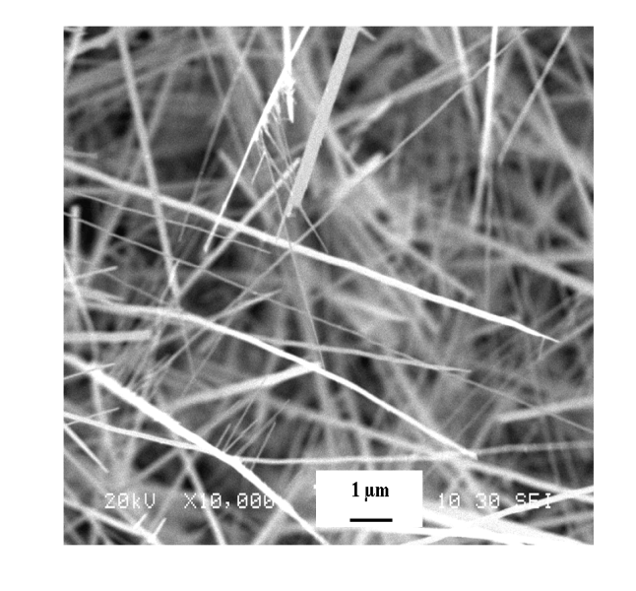
mμ 1

Figure 2. Figure definitions should be placed under the figure or image.

Table 1. Style Guide JRMBS Journal Checklist
Subtitle | Font
title HEADLINE | Times 17
Authors name | Times 11
Affiliation | Times 11
ABSTRACT | Times 11
Keywords | Times 11
Subtitle | Times 12, Bold
Text description | Times 10
figure definitions | Times 10
Factor and units, Equations | Times 11
References | Times 10

Table 2. Supplementary Materials Supported in JRMBS Journal.
Visualization | 2D image, 3D image, video
Data File | Small data file such as data underlying a plot in a figure
Dataset | Dataset stored in an appropriate external repository
Code | Code or simulation files stored in an appropriate external repository

  - Subtitle
Table 3. Table Header
1.Factor | 2.Unit | 3.Low | 4.High
Final temperatures | °C | 200 | 600
Heating rate | °C/min | 1 | 10
Holding time | Min | 0 | 60
N₂ flow rate | L/min | 0.2 | 1.0
Condensing temperature | °C | 0 | 10
Reference: author surname and publication date (eg: George, 2009).

Table 4. Table Header
Common Abbreviations and Misuses
Use√ | Do Not Use ⊗
µm | µ
nm | mµ
fm | F (F is for farad)
g | gm
A | amp
K | °K
sr | Sr, ster, str
u | amu
cm³ | cc
deg | DEG, DEG., deg.
keV | KEV, KeV
MeV | Mev, MEV
MeV/nucleon | MeV/u, MeV/amu, MeV/A
µ_{N} | n.m.
c.m. (=center of mass) | CM
arb. units | a.u. (for atomic units)

Table 5. Please Use: Preferred Notations, Notation Example and Style Notes.
Preferred Notations | Notation Example | Style Notes
nucleon number (mass number) | ¹⁴N | left superscript
state of ionization | Ca⁺² | right superscript
excited state | ¹¹⁰Ag^{m}, ¹⁴N* | right superscript
number of atoms in a molecule | ¹⁴N₂ | right subscript
bombarding particles | n, p, d, t, h, and 𝛼 | 𝜏 not acceptable
other beam particles | ⁶Li, ¹²C, ... | only the usual symbols
target nuclides | ¹H, ²H, ³H, ³He, ⁴He ... | not D, T, …
differential cross section | σ(ϑ), σ(E,ϑ) | i.e., angle or energy shown as argument
derivative | d²σ/dΩ dE | d²σ by itself or dσ/dΩdE not acceptable
mathematical relationship | dM/dA, ds/dZ | e.g., semiempirical mass formula; not acceptable for data characterization since A and Z are not continuous

- CONCLUSION
Please conclude your work incorporating your most important finding as well as future works (100 words).
- ACKNOWLEDGEMENT
Please acknowledge your research grant, organization, scholarship (where relevant)
- REFERENCES
Reference style
Indicate references by adding a number within square brackets in the text. You can refer to author names within your text, but you must always give the reference number, e.g., "as demonstrated [3,6]. Barnaby and Jones [8] obtained a different result ....".
Number references in the order they appear in your article.
Abbreviate journal names according to the List of Title Word Abbreviations (LTWA).
Examples:
Reference to a journal publication:
[1] J. van der Geer, T. Handgraaf, R.A. Lupton, The art of writing a scientific article, J. Sci. Commun. 163 (2020) 51 – 59. https://doi.org/10.1016/j.sc.2020.00372.
Reference to a journal publication with an article number:
[2] J. van der Geer, T. Handgraaf, R.A. Lupton, 2022. The art of writing a scientific article. Heliyon. 19, e00205. https://doi.org/10.1016/j.heliyon.2022.e00205..

